Project Design Phase-II
Technology Stack
(Architecture & Stack)
Date | 23 September 2026
Team ID | SWTID-2026-9408
Project Name | Streamlining IT Procurement: Automating Standard Laptop Orders with Flow Designer
Maximum Marks | 4 Marks

Technical Architecture:
The diagram below shows the layered architecture for the standard laptop procurement automation, followed by the component and characteristic details.

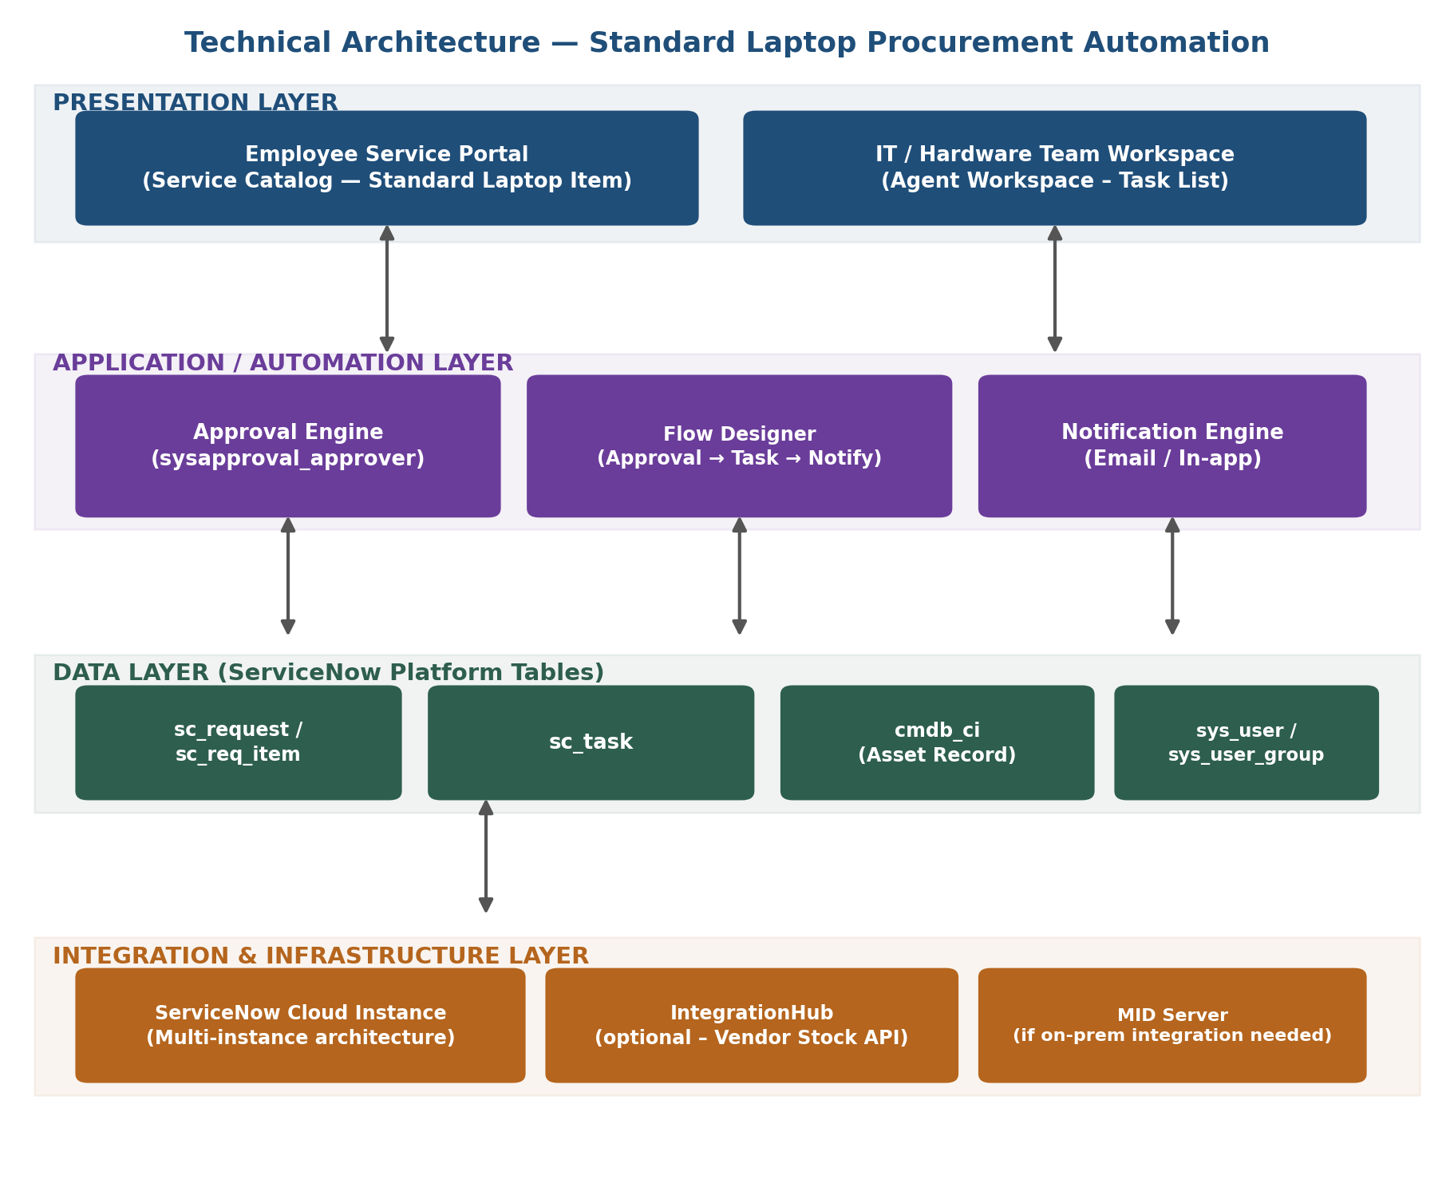

Table-1: Components & Technologies
S.No | Component | Description | Technology
1 | User Interface | How users interact with the application — request & track laptop orders | ServiceNow Service Portal / Employee Center, Now Experience UI
2 | Application Logic-1 | Handles catalog form logic, validations & auto-fill | Catalog Client Scripts, UI Policies (GlideScript)
3 | Application Logic-2 | Manages manager approval routing & decisions | ServiceNow Approval Engine (sysapproval_approver)
4 | Application Logic-3 | Orchestrates the automation: trigger → approval → task → notify | Flow Designer (Flows, Actions, Subflows)
5 | Database | Stores requests, tasks and configuration data | ServiceNow platform tables (sc_request, sc_req_item, sc_task)
6 | Cloud Database | Underlying data store for the ServiceNow instance | ServiceNow multi-instance cloud database
7 | File Storage | Stores attachments such as configuration checklists | ServiceNow Attachments (sys_attachment)
8 | External API-1 | (Phase-2) Real-time stock / delivery ETA from vendor | Vendor REST API via IntegrationHub
9 | External API-2 | Sends email / chat notifications to users | ServiceNow Notification Engine, MS Teams / Slack (optional)
10 | Machine Learning Model | Not used in Phase-1; future scope: auto-categorize requests | ServiceNow Predictive Intelligence (future)
11 | Infrastructure (Server / Cloud) | Build, test & run the automation | ServiceNow PDI (dev/test), Production cloud instance

Table-2: Application Characteristics
S.No | Characteristics | Description | Technology
1 | Open-Source Frameworks | ServiceNow is a proprietary low-code platform; the catalog UI renders via the Now Experience Framework | Now Experience UI Framework (Angular-based, internal)
2 | Security Implementations | Access restricted by role; SSO login; every flow action is logged | ACLs, SSO / OAuth, sys_audit logging
3 | Scalable Architecture | Built on ServiceNow's horizontally scalable multi-instance cloud; automation split into reusable subflows | ServiceNow Cloud Architecture, Flow Designer Subflows
4 | Availability | Inherits ServiceNow's platform uptime SLA; the flow retries automatically on transient failure | ServiceNow 99.8% Uptime SLA, Flow Engine auto-retry
5 | Performance | Flow actions run asynchronously so they don't block the requester; catalog scripts avoid heavy synchronous queries | Async Flow Engine, optimized GlideRecord queries

